You must’ve observed small or large pop-ups at the bottom corner when you open a website. These welcome wishes usually greet you or share an incentive for new users.

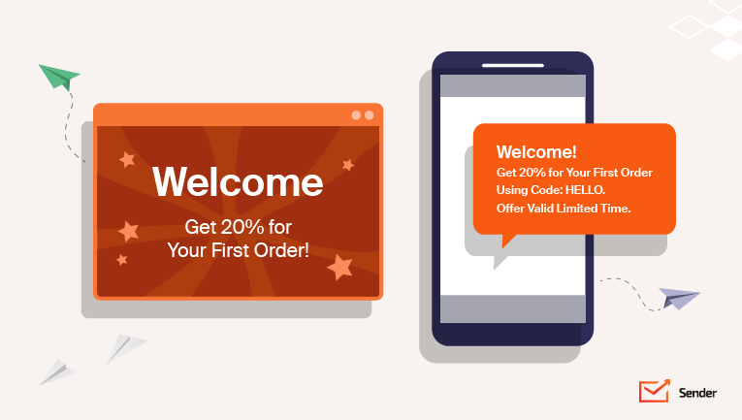

All these messages, popups, and texts welcome you to the website and fall into the category of welcome messages.

Welcome messages are not limited just to websites. They’re common across all customer touchpoints. There are welcome SMSs for customers, [welcome emails](https://www.sender.net/blog/welcome-email-examples/), welcome emails from the support desk when you contact them, and even a welcome call from the sales/customer success team in case of high-value products.

All these warm greeting messages and welcoming sayings are sent to leave a great first impression on the prospect or customer.

Wouldn’t it be nice to have one tool both for newsletters and texts? Send your email & SMS campaigns from a single dashboard with Sender.

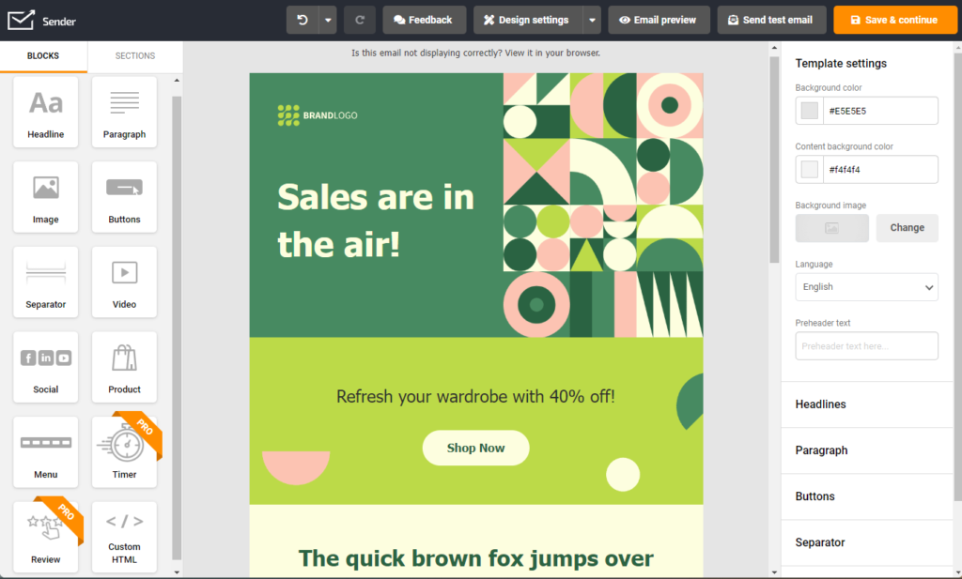

[Get Started For Free](https://auth.sender.net/register)

**How to Create Welcome Messages?**

A welcome message is the first branded experience for your prospective customers. It helps build a perception of your brand, service, and product offerings. As first impressions matter a lot in our world, you must pay attention to sending a great welcome message every time.

Here are some best practices to help you create **the perfect welcome message**:

* Don’t use spammy words in your subject line. Make them feel they’ve made the right choice by sharing their email address or phone number;
* Introduce yourself as a human, make them feel appreciated, and reassure them that their personal information is safe;
* Tell them what to expect from you as a brand in the future;
* Strike a conversation by asking them a question in the email to ensure your future emails don’t end up in spam;
* Create a contextual CTA to prompt them to try your product or offering in case you’re giving away a coupon, deal, or downloadable in your welcome email;
* Never include more than one call to action in your welcome email. Doing so can confuse the recipient, and no one likes a confused stranger.

**Welcome Message Examples**

We’ve got you covered if you’re short on ideas on using welcome messages in your marketing campaigns. Here are the most relevant scenarios and examples to send a warm welcome message. Use these to welcome a team member, customer, prospect, or anyone interacting with your business.

**Short Welcome Message**